Mid Tearm
Pdf - 01
1. What is Microprocessors?
Ans: Microprocessor is the core of computer systems. A microprocessor is a multipurpose, programmable, clock-driven, register based electronic device that reads binary instructions from a storage device called memory.
2. Why do we need to learn Microprocessors and Microcontrollers?
Today there is no electronic gadget on the earth which is designed without a Microcontroller. Ex: communication devices, digital entertainment, portable devices etc...
- Personal information products: Cell phone, pager, watch, pocket recorder, calculator.
- Laptop components: mouse, keyboard, modem, fax card, sound card, battery charger
- Home appliances: Door lock, alarm clock, air conditioner, Tv remote etc.
- Industrial equipment: Temperature/pressure controllers, Counters, timers, RPM Controllers
- Toys: video games, cars, dolls, etc.

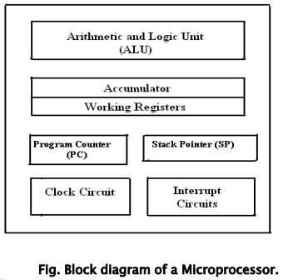
3. Explain Microprocessor with block diagram.
i. Arithmetic and Logic Unit (ALU) : It is the place where
actual computations take place. Consist of circuits which
performs arithmetic operations.

ii. Control Unit (CU): The coordination and control of a
computer is the sole responsibility of the Control Unit.

iii. Registers: Registers are temporary storage locations inside
microprocessor that holds data and address.

iv. Program counter (PC): It is commonly known as IP (Instruction
Pointer) in 8086, is a register in microprocessor that contains the
address of the next instruction to be executed.

v. Stack Pointer (SP): It is a small register that stores the address of
the last program/instruction request in a stack.

4. Microprocessor:
- CPU for Computers
- No RAM, ROM, I/O on CPU chip itself
- Example: Intel's x86, Motorola’s 680x0
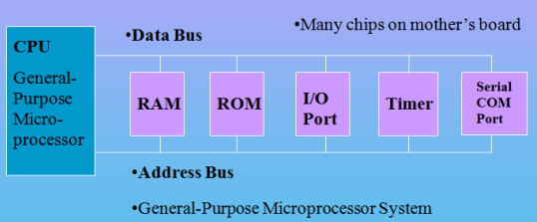

5. What is Microcontroller?
Ans: A microcontroller is a highly integrated single chip, which consists of on chip CPU (Central Processing
Unit), RAM (Random Access Memory), EPROM/PROM/ROM (Erasable Programmable Read Only Memory), I/O (input/output) – serial and parallel ports, timers, interrupt controller.
For example: Intel 8051 is 8-bit microcontroller and Intel 8096 is 16-bit microcontroller.
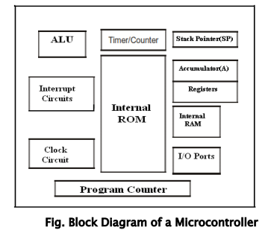
6. Block Diagram of Microcontroller:

7. Applications of Microcontrollers:
Cell phone, Pager, watch, calculator, video games, Alarm clock, air conditioner, Tv remote, Microwave oven, washing machines, robotic system, anti-lock braking system monitor.
8. Microcontroller:
- A smaller computer
- On-chip RAM, ROM, I/O ports...
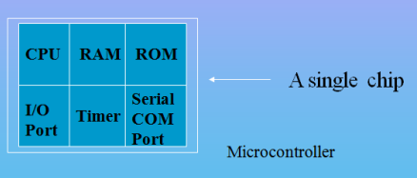
- Example: Motorola’s 6811, Intel’s 8051, Zi log’s Z8 and PIC

9. What is RISC (Reduced Instruction Set Computer)?
It stands for Reduced Instruction Set Computer. It is a type of microprocessor architecture that uses a small set of instructions of uniform length. These are simple instructions that are generally executed in one clock cycle. RISC chips are relatively simple to design and inexpensive. Examples: SPARC, POWER PC etc.
10. What is CISC (Complex Instruction Set Computer)?
It stands for Complex Instruction Set Computer. These processors offer the users, hundreds of instructions of variable sizes. CISC architecture includes a complete set of special-purpose circuits that carry out these instructions at a very high speed. CISC processors reduce the program size and hence lesser number of memory cycles are required to execute the programs. This increases the overall speed of execution.
Examples: Intel architecture, AMD
11. Distinguish with Microprocessor and Microcontroller.
Microprocessor | Microcontroller
CPU is stand-alone, RAM, ROM, I/O, timer is separate | CPU, RAM, ROM, I/O and timer are all on a single chip
General-purpose | Single-purpose (control-oriented)
Designer can decide on the amount of ROM, RAM and I/O ports. | Fixed amount of on-chip ROM, RAM, I/O ports
High processing power | Low processing power
Typically, 16/32/64 – bit | Typically, 8/16 bit
Typically, deep pipeline (5-20 stages) | Typically, single-cycle/two-stage pipeline

12. Distinguish with RISC and CISC.
RISC | CISC
RISC stands for Reduced Instruction Set Computer. It’s focus on software. | CISC stands for Complex Instruction Set Computer. It’s focus on Hardware.
Uses only Hardwired control unit. | Uses both hardwired and microprogrammed control unit.
Can perform only Register to Register Arithmetic operations | Can perform REG to REG or REG to MEM or MEM to MEM
RISC is Reduced Instruction Cycle. | CISC is Complex Instruction Cycle.
Simple and limited addressing modes. | Complex and more addressing modes.
Code size is large | Code size is small
Here, addressing modes are less. | Here, addressing modes are more.

Pdf – 02
1. Explain the 8086 Microprocessor
- It is a 16-bit microprocessor
- It has 16-bit data bus
- It has 20-bit address bus
- 8086 CPU is divided into two independent functional parts.
- Bus interface unit (BIU)
- Execution unit (EU)

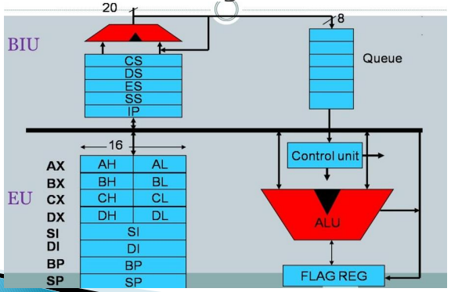
2. Draw the 8086 internal block diagram and explain the Bus Interface Unit(BIU) and Execution Unit(EU)

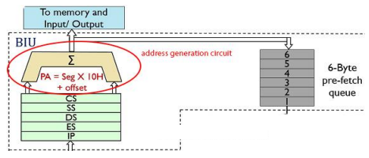
***Bus Interface Unit:
1. Instruction Queue-
- 6-byte queue
- Prefetch instructions (FIFO)
2. Segment Register-
Start address of a data. It has 4 segment registers that holds address of instruction and data in memory.
- Code Segment register
- Data Segment register
- Extra Segment register
- Stack Segment register
3.Instruction Pointer –
It’s a 16 bit register that holds offset of the next instructions in the CS.

***Execution Unit in 8086:
This is an execution unit where instruction decoding and execution takes place.
1. General Purpose Register : Four 16 bit register divided into 2 parts low [8bit] and high [8bit] use for data handling.
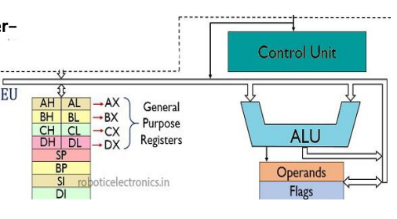
i. AX iii. CX
ii. BX iv. DX

2.Pointers register : contain offset address.
- SP(Stack pointer)- point to stack, top of stack segment.
PA= [SS] *10H +[SP]
- BP(Base pointer)- use to access random location of stack.
PA=[DS] *10H+[BP]
3. Index register:
- DI (Destination Index)
- SI (Source Index)
4. Temporary register: Store temporary
5. ALU : Perform arithmetic and logical Operation.
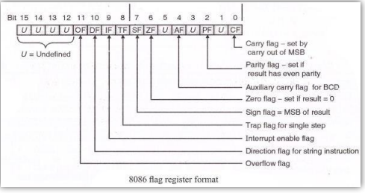
3. Explain Flag registers with diagram/ format

The flag register is a 16-bit register in the Intel 8086 microprocessor that contains information about the state of the processor after executing an instruction. There are two types of flag register:
1) conditional/status and 2) control flag
1. Conditional/ Status flag:
- Carry flag- It is set whenever there is a carry or borrow out of the MSB (most significant bit) of a result. D7 bit for an 8-bit operation and D15 bit for a 16-bit operation.
- Auxiliary carry flag- this flag is set when ALU perform BCD operation of 8-bit and if result in a carry or borrow.
- Parity flag- It is set if the result has even parity. If parity is odd, PF is reset.
- Zero flag- This flag is set 1 when the result of ALU operation is zero else it is set to zero.
- Sign flag- It is set if the MSB of the result is 1.
- Overflow flag- It will be set if the result of a signed operation is too large to fit in the number of bits available to represent it.
2. Control Flag:
- Trap flag- It is used to set the trace mode i.e. start single stepping mode.
- Interrupt flag- this flag is used to enable or disable interrupt. It is set to 1 for interrupt enabled and set to 0 for interrupt disabled
- Direction flag- It is used in string operation.
Pdf – 3
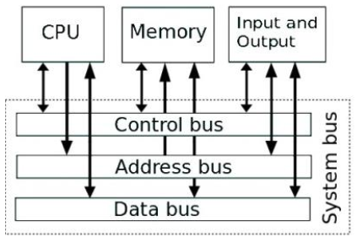
1. Function of 8085 with diagram.
Ans:
• Bit: A bit is a single binary digit.
• Word: A word refers to the basic data size or bit size that can be processed by the
arithmetic and logic unit of the processor. A 16-bitbinary number is called a word in a 16-bit
processor.
• Bus: A bus is a group of wires/lines that carry similar information.
• System Bus: The system bus is a group of wires/lines used for communication between the microprocessor.
• Address Bus: It carries the address, which is a unique binary pattern used to identify a memory location or an I/O port. For example, an eight-bit address bus has eight lines and thus it can address 2^8 = 256 different locations.
• Data Bus: The data bus is used to transfer data between memory and processor or between I/O device and processor. For example, an 8-bit processor will generally have an 8-bit data bus and a 16-bit processor will have 16-bit data bus.
• Control Bus: The control bus carry control signals, which consists of signals for selection of memory or I/O device from the given address.
2. Functions of Control Unit of 8085.
Ans: • Data Bus: Data bus carries data in binary form between microprocessor and other external units such as memory. Data bus is bidirectional in nature. The data bus width of 8085 microprocessor is 8-bit. 2^8 combination of binary digits and are typically identified as D0 – D7.
• Address Bus: The address bus carries addresses and is one-way bus from microprocessor to the memory or other devices. 8085 microprocessors contain 16-bit address bus and are generally identified as A0 - A15. the eight data bits (D0 – D7) and hence, they are bidirectional.
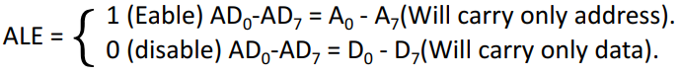
• Control Bus: The control bus carries control signals partly unidirectional and partly bidirectional. The following control and status signals are used by 8085 processor:
I. ALE (Address Latch Enable):
II. RD (active low output): when the RD = 0, it will do read operation.
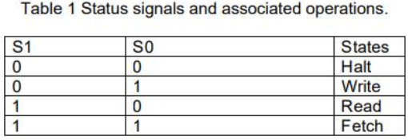
III. WR (active low output): when the WR = 0, it will do write operation.
IV. IO/M : It is a signal that distinguishes between a memory operation and an I/O
operation.
V. S1 and S0: These are status signals used to specify the type of operation being
performed; they are listed in Table 1.

Pdf – 4
1. Function of control Unit of 8086.
• Data bus: Carries data in binary form between microprocessor and other external units and vise-versa. The data bus width of 8086 microprocessor is 16-bit. 2^16 combination of binary digits and are typically identified as D0 – D15.
• Address Bus: It contain 20 bit address bus and identified as A0-A19.
o (AD0 –AD15) [Address/data bus]: address bus are multiplexed with (D0-D15) data bus.
o (A16/S3 –A19/S6) [Address/status bus]: there are 4 address/status bus.
• Control bus: Carries control signals. The following control and status signals used in 8086 microprocessor.
Pin in max mode-

o BHE/S7- bus high enable is an active low signal, so it active when BHE= 0.
o RD- this is used for read operation when RD = 0.
Pin in min mode-
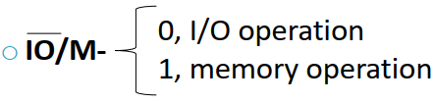
o WR- 0, then write operation active.
o ALE- address appears on (AD0-AD15).

Pdf- 5
1. What is Addressing Modes?
Ans: The various formats of specifying the operands are called addressing modes.
2. Memory Addressing Modes.
In this addressing mode, one operand (source or destination) of an instruction must be an address of a memory location, which will be calculated by PA.
PA= [Segment] x 10H + Offset
Example: Offset or EA= [ARRAY] + [BX] + [SI] = 2AH + 5000H + 2000H = 702AH

3. Explain Six types of memory addressing mode.
i. Direct or Displacement Addressing mode: In this mode, the EA is directly given in the instruction.
Example: MOV AX, [0500]; EA=0500H, AX will get data from 0500H address.
ii. Register Indirect Addressing mode: In this mode, the EA is in SI, DI or BX, which is calculated by PA.
PA= [DS] x 10H+EA
Example: MOV AL, [SI]; Calculated PA=21200H is the address of memory location.
iii. Based Addressing mode: In this mode, the EA is calculated by adding the contents of BX or BP and a displacement (variable).
So, PA= [DS]x10H+EA
Example: MOV BL,ARRAY[BX]; Calculated PA=32105H is the address of memory location
iv. Indexed Addressing mode: In this mode, the EA is calculated by adding the contents of SI or DI and a displacement (variable).
So, PA= [DS]x10H+EA
Example: MOV AL,START[SI]; Calculated PA=12403H is the address of memory location
v. Based Indexed Addressing mode: In this mode, the EA is calculated by adding the contents of BX or BP, SI or DI and a displacement (variable).
So, PA= [DS]x10H+EA
Example: MOV CL, DISPLACEMENT[BX][SI]; Calculated PA=81A07H is the address of memory location
vi. String Addressing mode: This addressing mode is related to string instructions.
Example: MOVS B ; MOVS Move the string, B Byte
MOVS W ; MOVS Move the string, W Word

4. Math.
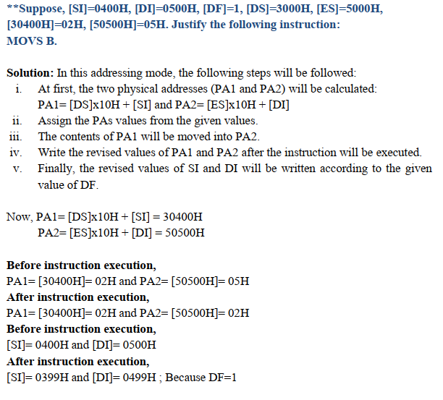

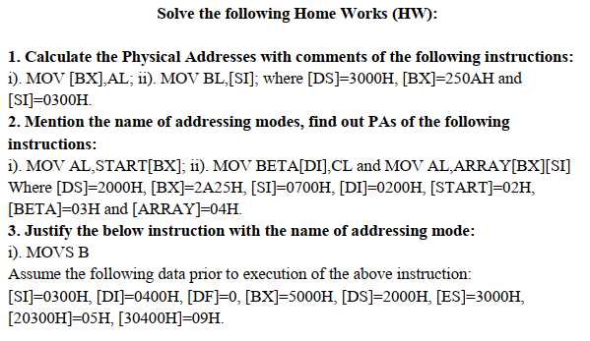

Lab Pdf
1. What is Assembly Language?
- Assembly language is a low-level language that helps to communicate directly with computer hardware. An assembler is used to convert assembly code into machine language.

- Assembly languages contain mnemonic codes that specify what the processor should do. Ex – ADD for addition, SUB for subtraction.

2. Syntax of Assembly Language.
Assembly language code is generally not case sensitive. but we use upper case to differentiate code from the rest of the text.
Statements:
Programs consist of statements, one per line. Each statement is either an instruction, which the assembler translates into machine code, or an assembler directive.

name | operation | operand(s) comment

. An example of an instruction is :
START: MOV CX,5 ;initialize counter

Here, the name field consists of the label START: The operation is MOV, the operands are CX and 5, and the comment is ; initialize counter.

3. Name Field.
Ans: i. The name field is used for instruction labels, procedure names, and variable names.
ii. Names can be from 1 to 31 characters long, and may consist of letters, digits, and special characters like ?, @, _, $, % .
iii. Some Example of legal names : diu_25, diu@cse, .Test, Done?
iv. Some Example of illegal names : TWO WORDS, 2abc, A45.28, You&ME

4. Operation Field.
Ans: MOV, ADD, SUB

